1. less f1 : it will load the data less in the file to access we can pres -p to the previous line and -n it will print the line numbers and q it will quit the filename

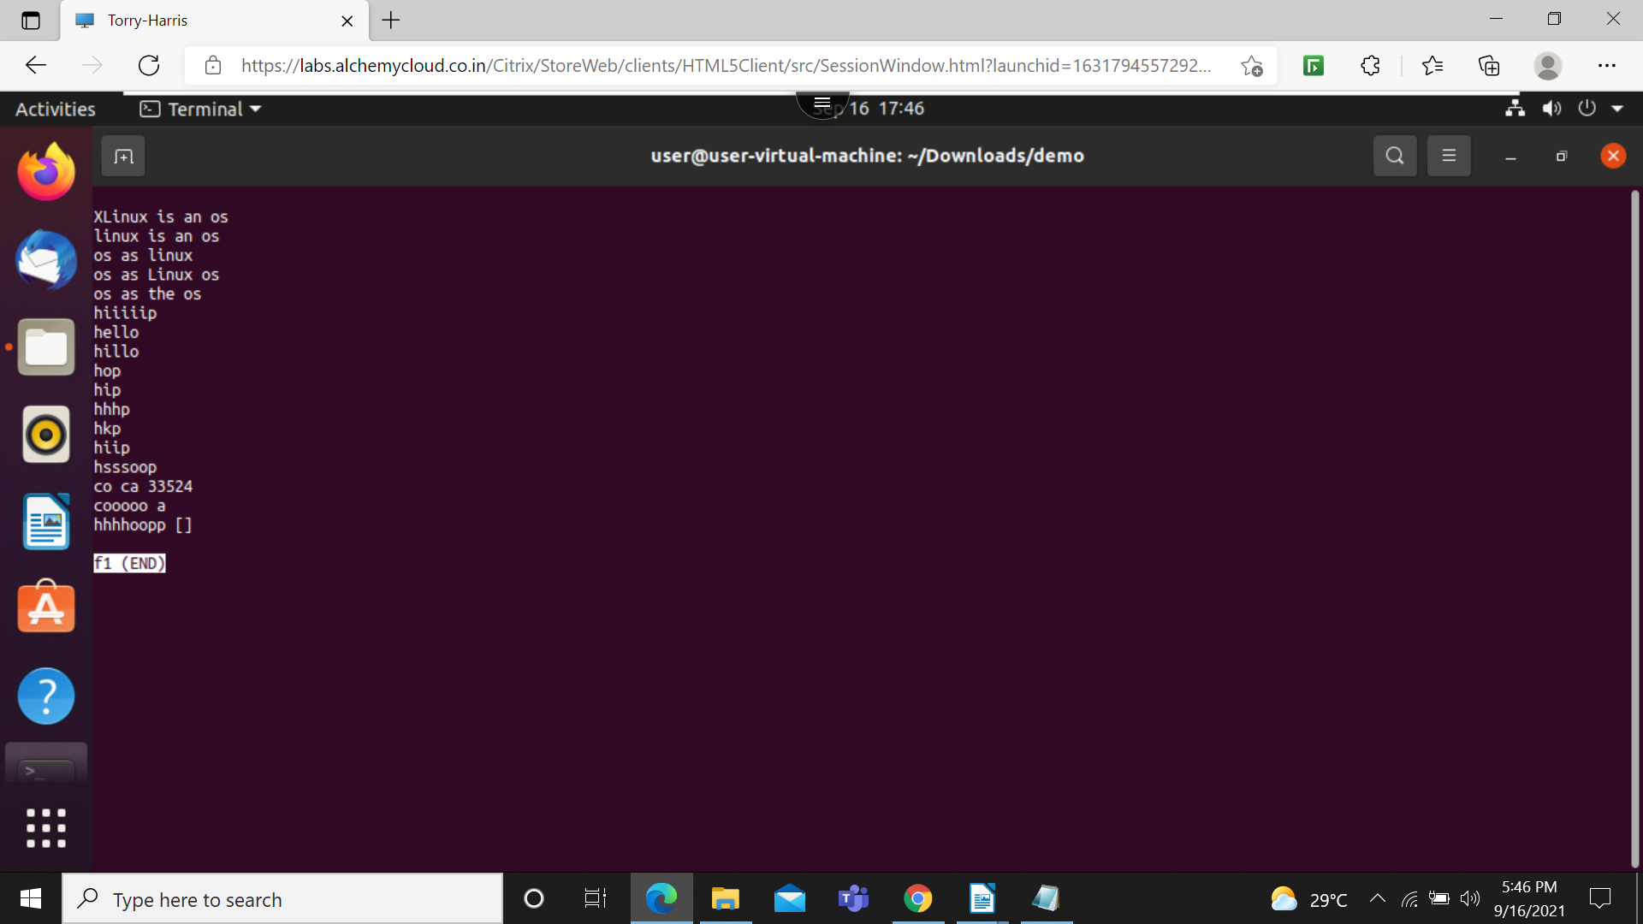

Vim: it use to reda and edit the data from on efile to other file
- I: is use to insert the data to the file through vim

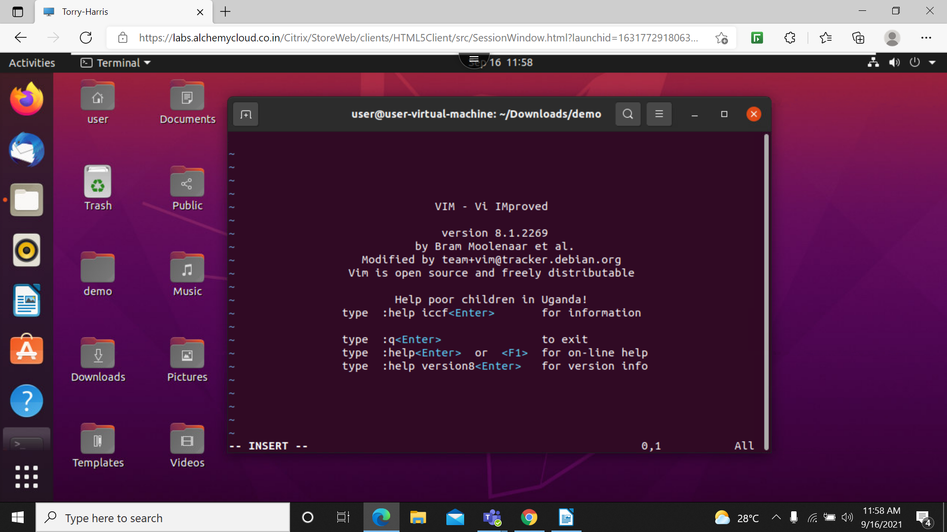

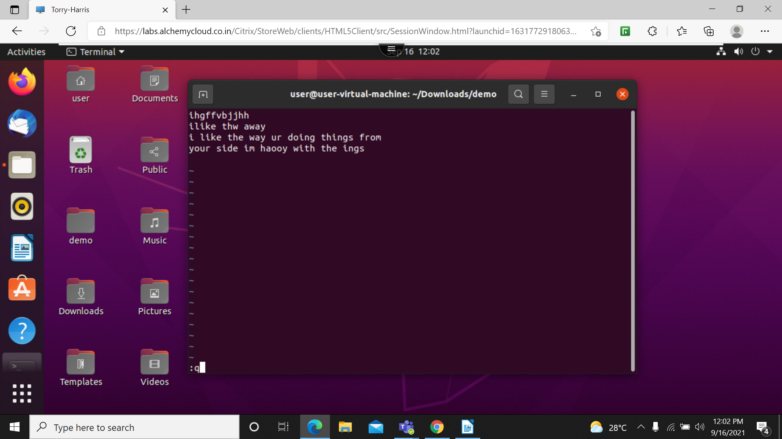
2. :q> is use to exit from the terminal of vim

3. :w > is use to save the file
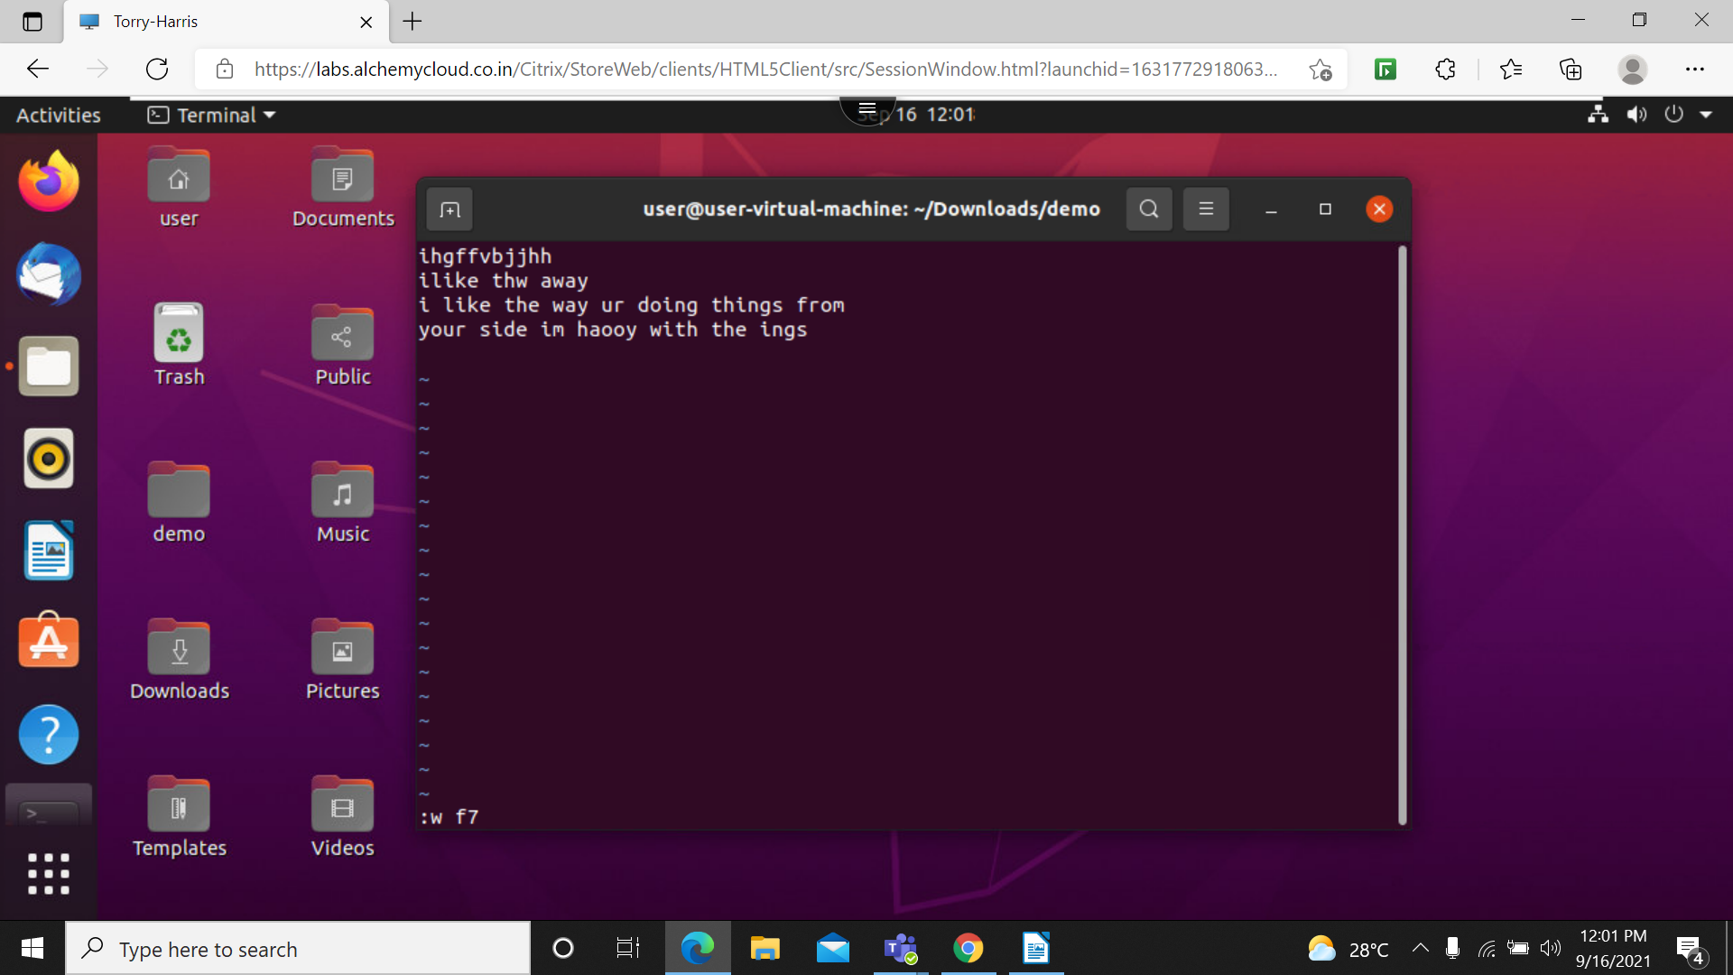

4. :r > is use read and copy the data from one file to other file

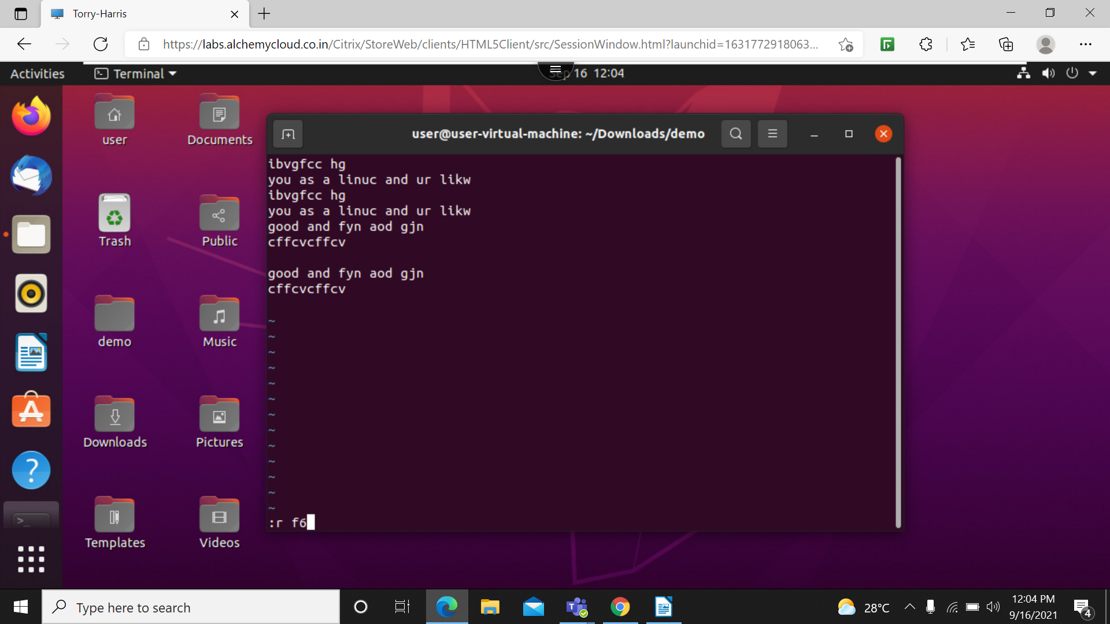

5. :r f6 and :w f5 : it will copy the data from f6 and it will save the file( open file f6 then :r f5 it will copy data from f5 to f6 and :w it will save the data)

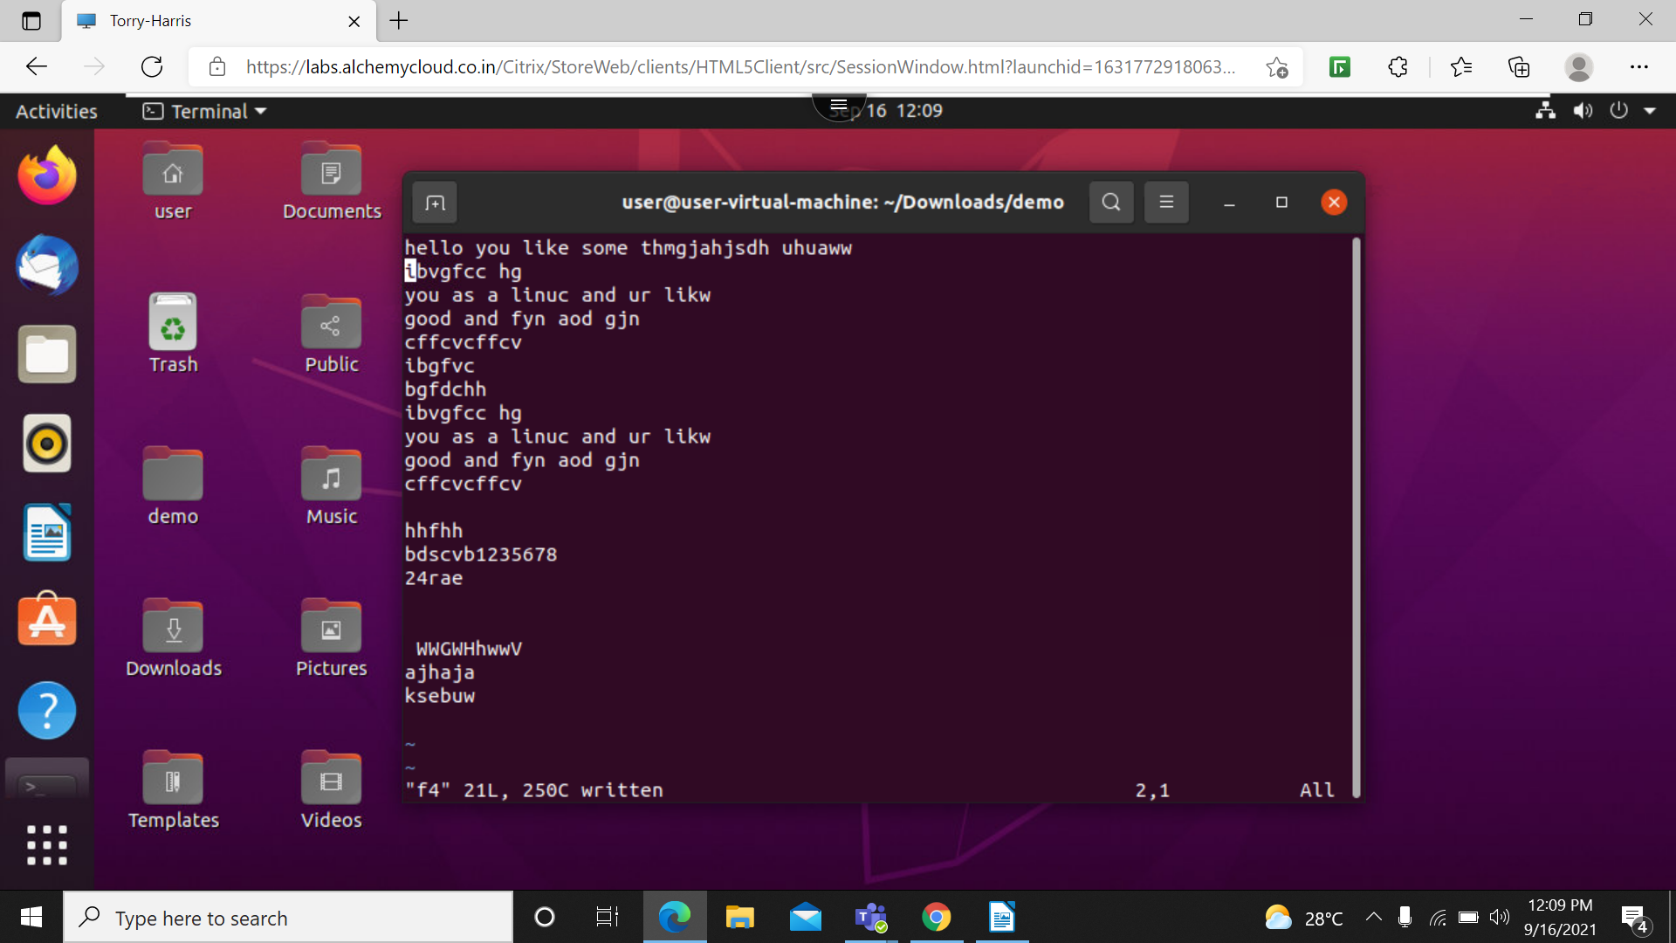

6. cat f4: it will read the data of file f4
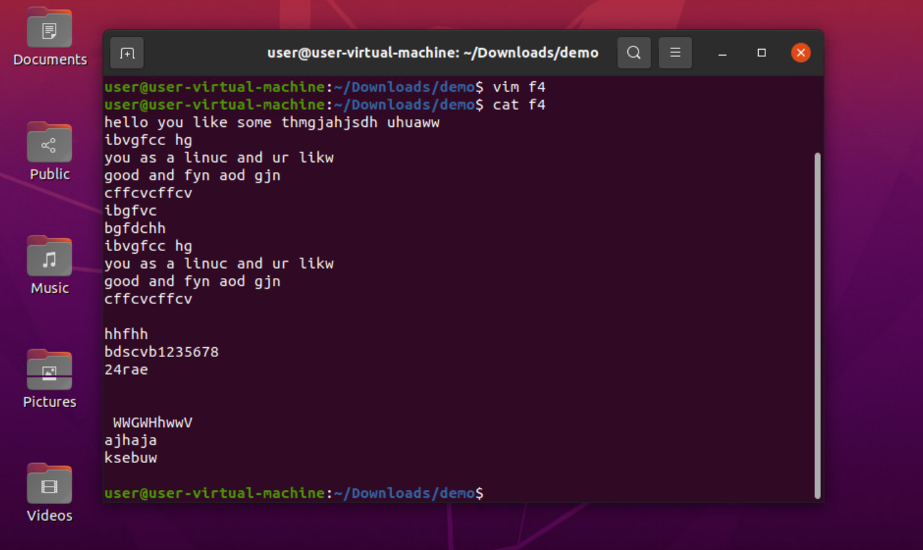

7. find: this command use to find the all fies in system r directory
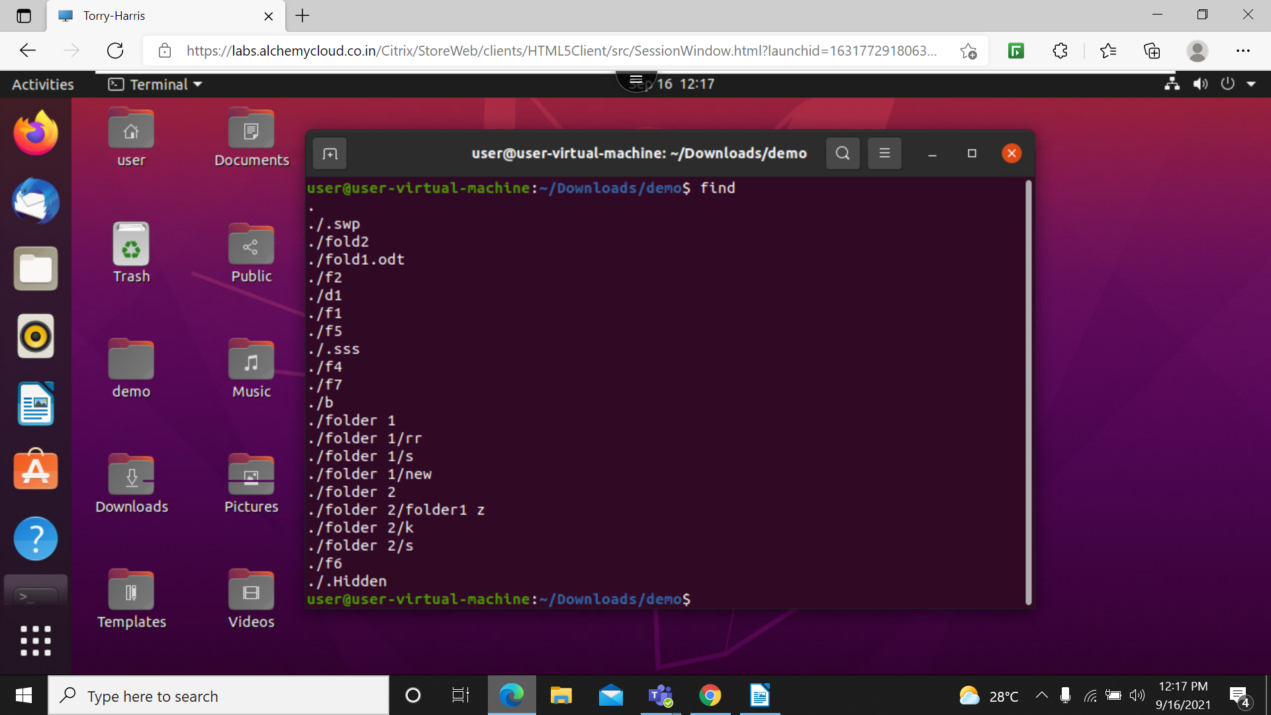
t

8. find -name f1: this will give location of the file
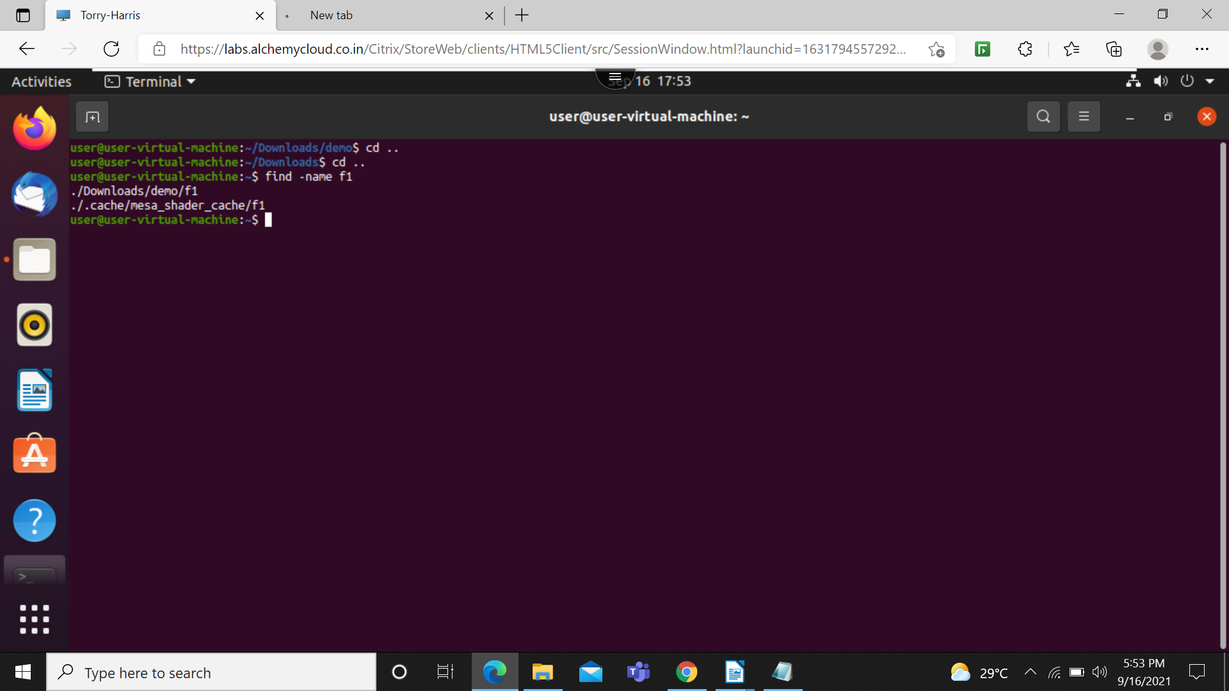

9. head: it will print the first 10 line
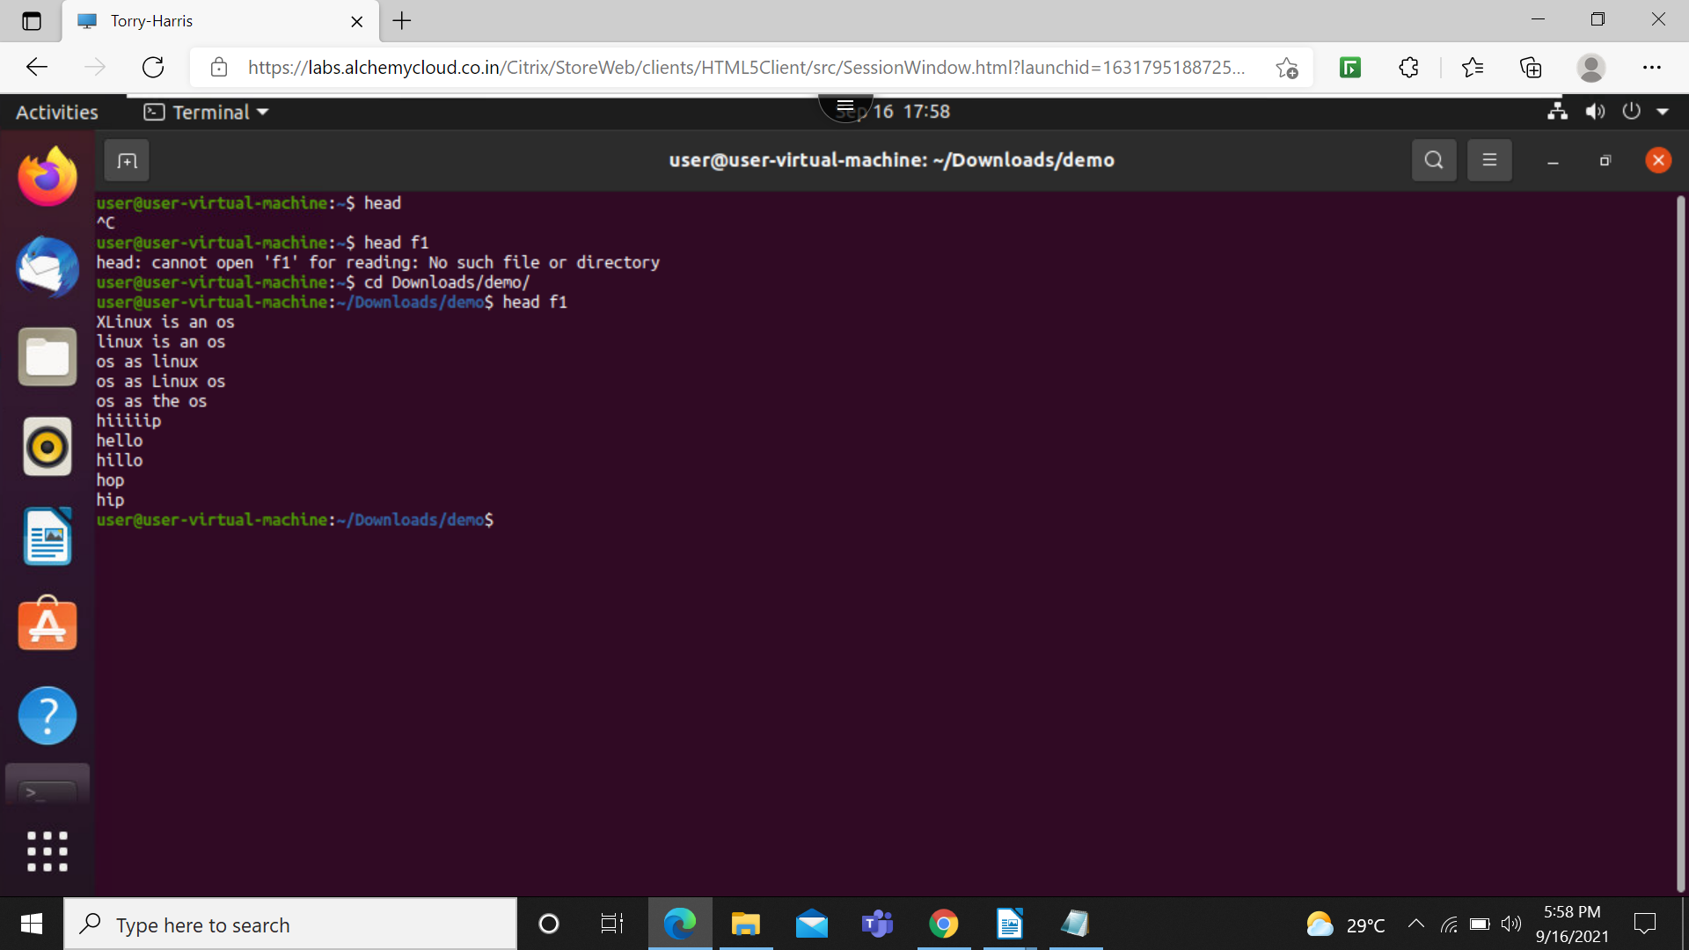

10. head -n 6 f1: this will display the first 6 lines

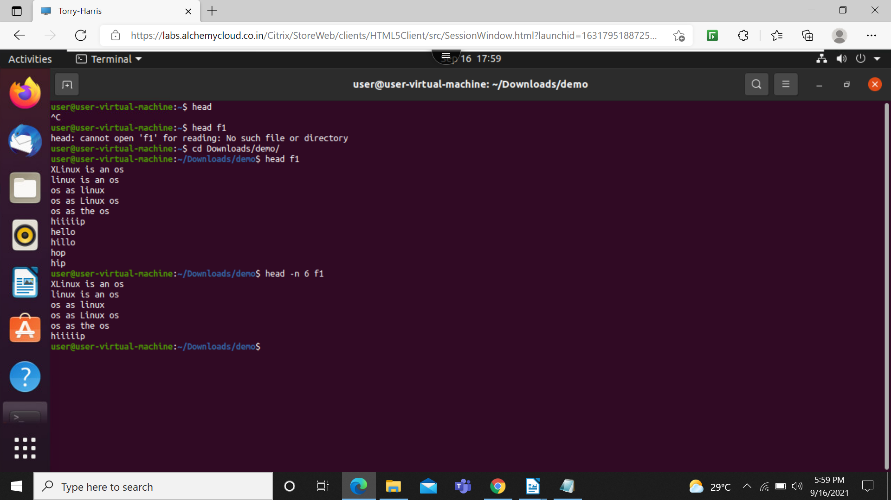

11. head -q f1 f2: this will print the first 10 lines of a file
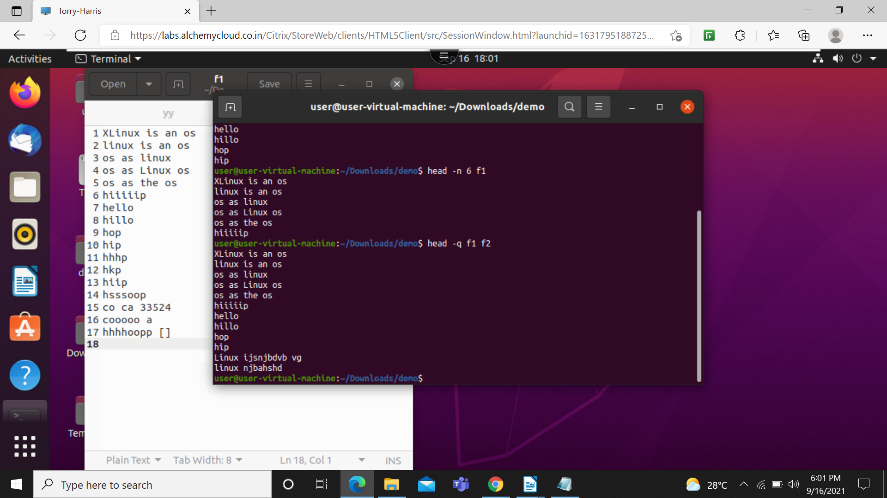

12. head -v f1: it will print file name as well folder name
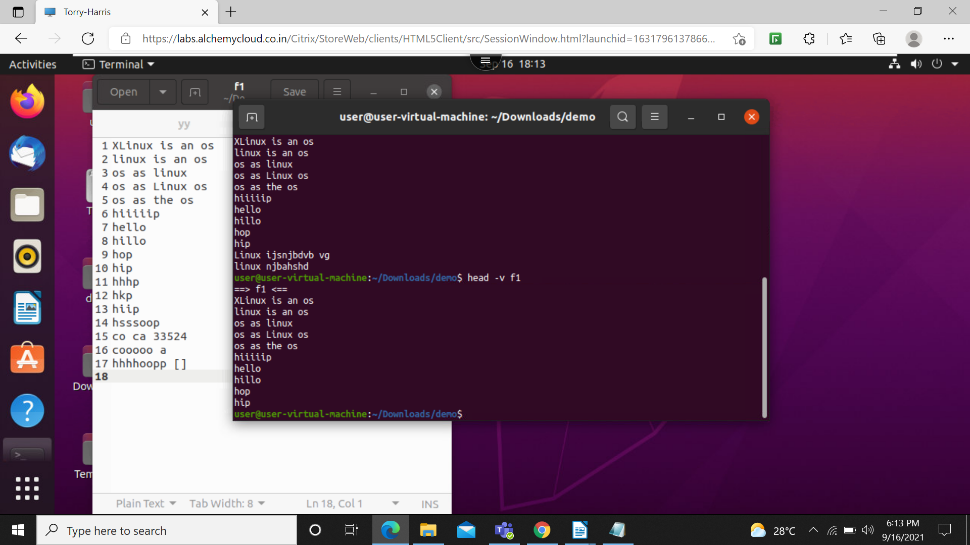

13. tail f1 : will print the last 10 lines from the file
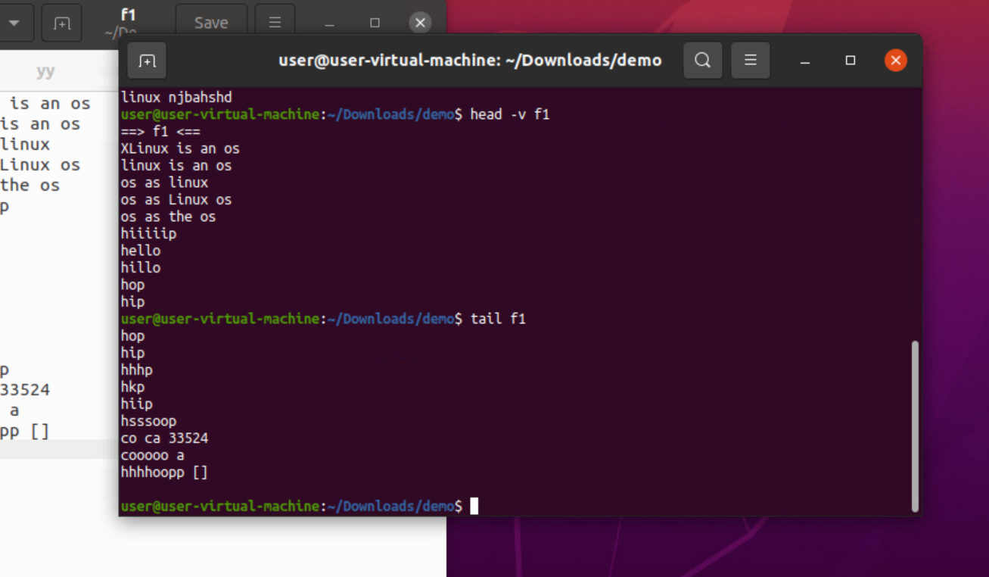

14:tail -n 6 f1: this will print last 6 lines from the file
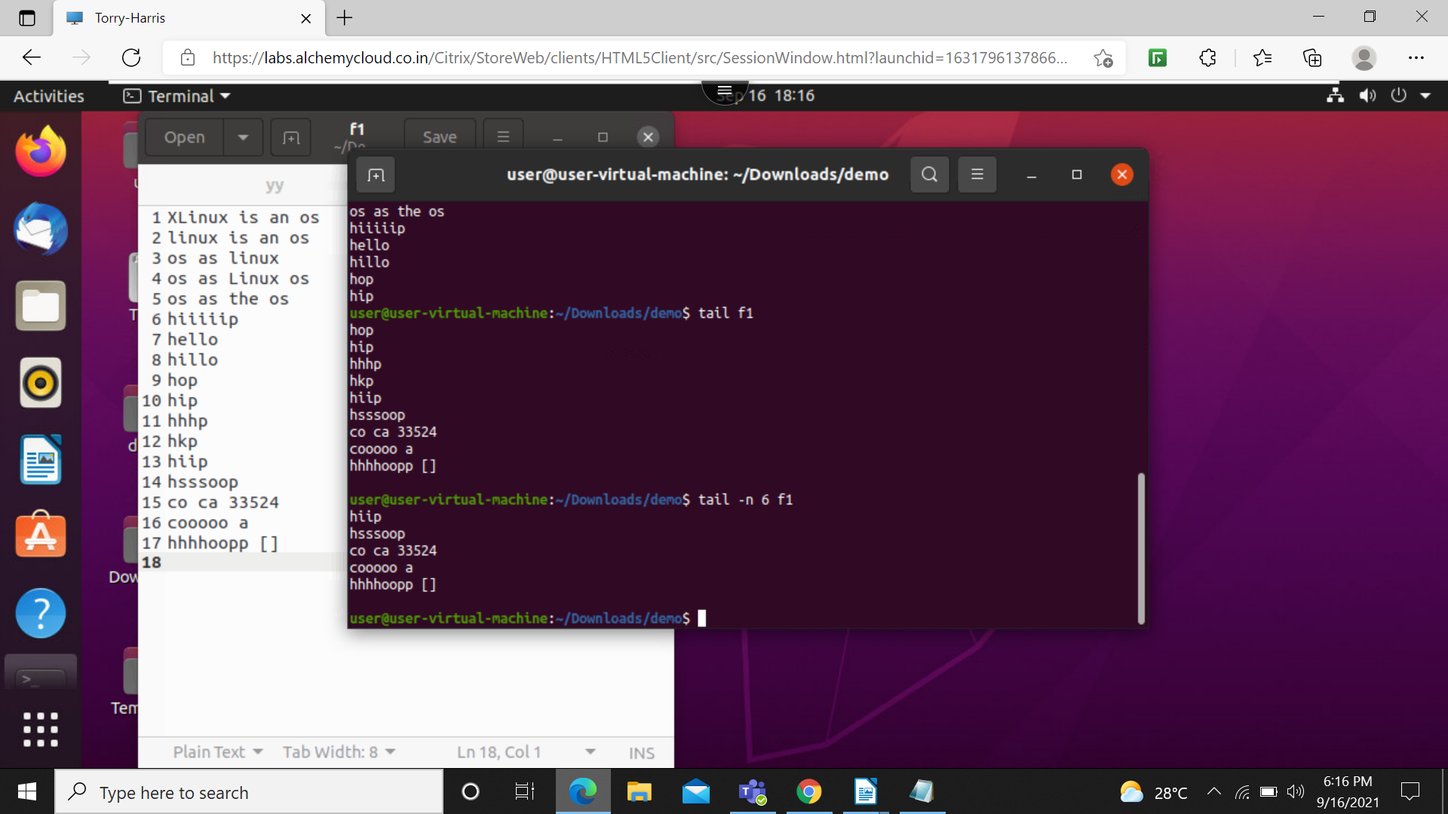

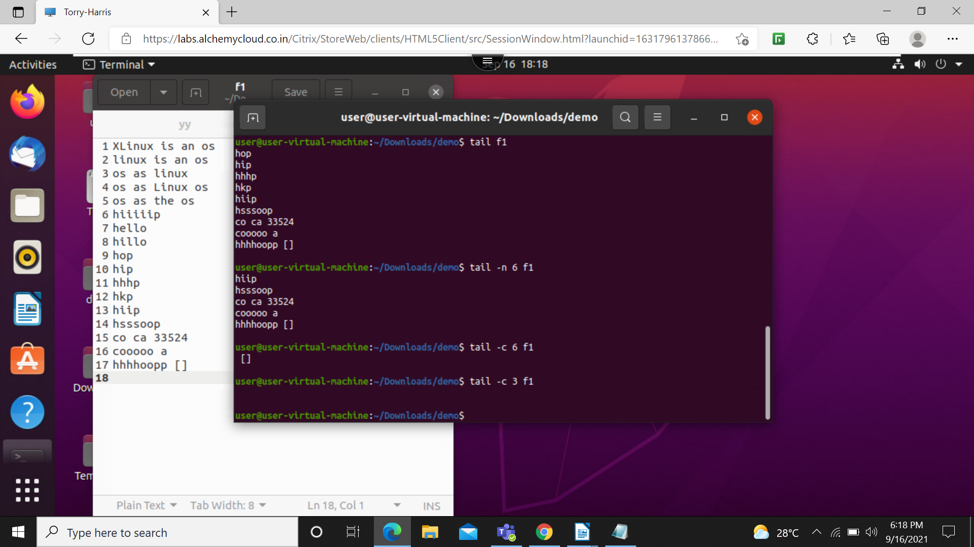
15. tail -c 3 f1: this will print the last 3 line of filename

16. tail -q f1 f2: will add 2 files it will give the last 10 line
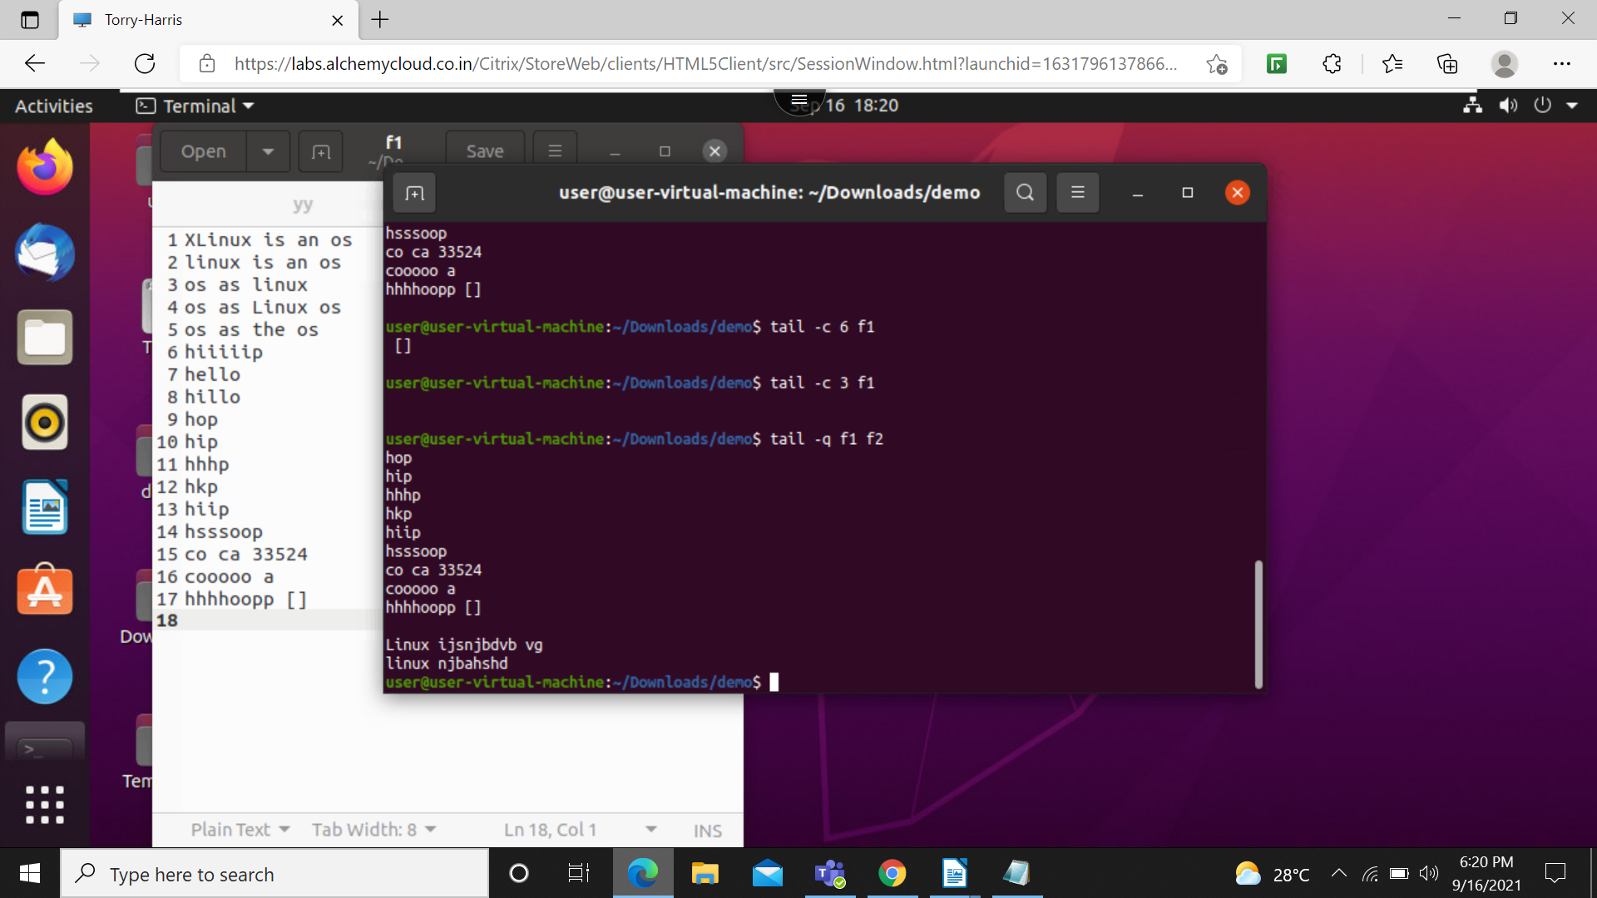

17. tail –version: this will print the version of the file


